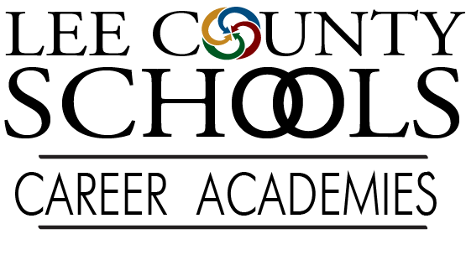

What are career academies?
Lee County Schools Career Academies, in partnership with the parents and community, are committed to preparing students for service and leadership in the hospitality and tourism, engineering and finance industries. Our mission is to ENCOURAGE achievement and social responsibilities, ENGAGE students through real-world experiences, and ENABLE students to grow and be versatile amidst industry change.
Benefits of being an academy student:

- PAID internships available for students during their senior year

- Opportunity to take college courses at Central Carolina Community College

- Academy students can also earn 1-year certificates at CCCC including:
  - Tax Payers Certificate
  - Culinary Certificate
  - Social Media Marketing Cert.

- Advisory Board consisting of local business leaders who will advise both teachers and students to ensure that the academies are successful

National Academy Foundation (naf.org)

Lee County Career Academies work with the National Academy Foundation

The National Academy Foundation (NAF) has more than 565 academies across 38 states and include more than 70,000 students. NAF celebrates a 96% graduation rate among its students as a result of the collaboration of dedicated educators, business partners and hard-working students.

NAF is a leader in the movement to prepare young people for college and career success.

NAF has refined a proven educational model which includes:
- Industry-focused curriculum
- Work-based learning experiences
- Community business partner involvement

Number of NAF Academies By Theme in NC:

7- Hospitality and Tourism 9- Finance 13- Engineering

Students in the academy also have the opportunity to receive NAF Track Certification. This is a partnership with major companies including AT&T, Cisco, HP, JP Morgan Chase, KPMG, Verizon, Xerox, Marriott and many more!

The NAF Track Certification provides:
- College internship opportunities
- Guaranteed interviews with these companies
- Priority hiring among equally qualified applicants
- Potential higher starting salary and much more!

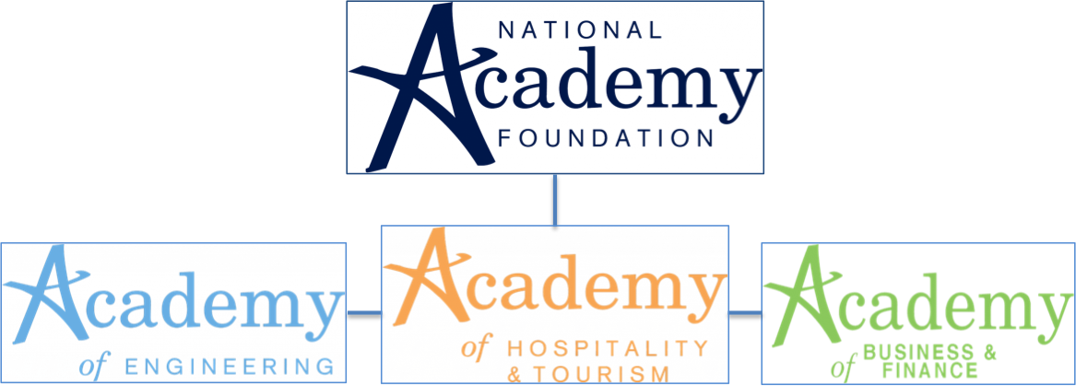

Frequently Asked Questions:

- What is a Co-Hort?
A Co-Hort is a group of classes that have a similar NAF academy Theme pairing them together. Each theme is placed with two core classes to strengthen cross-curricular subject matter. These students will be placed in the same classes to provide better opportunities for overlapping.

Hospitality and Tourism Social Studies and English
Engineering Math and Science
Business and Finance Math and Social Studies

- Can you sign up after 9th grade year?
In years prior students have been able to join an Academy during their 10th year, which is called “Fast-Tracking.” This means that the student would take the 9th grade course and 10th grade course the same year.

However, due to the current sizes of the Academies, there is not a plan to accept Fast Track students for the upcoming year.

- What if I don’t like being in the Academy?
Students will have the opportunity to remove themselves from the Academy if they do not like the course work. However, once a student is removed from the Academy they will not be allowed back in.

- Are Academies Honor’s Credit?
All academies are concerted to be Honor’s Academies. Each course taken in these Academies are at Honors Level.

- Can I be in multiple Academies?
Due to the amount of classes or the length of classes in each Academy it is not typically recommended that students be enrolled in more than one Academy.

- Can students be removed from the Academy?
Students can be removed from their Academy a few ways. A student can remove themselves at the end of the semester if they wish. A student can also be placed on probation for not following rules or guidelines of the academy. If behavior, grades or attendance is not improved the student will be removed.

- Is Southern the only high school with NAF Academies
No, both high schools offer the same Academy selection. Each school has partnered together as much as possible throughout the planning and implementation of each theme.

